PRC Configuration

General Site.

- What color should the header and footer be? Like he has done is great
- What is the site name? Displayed in the header Blue as it was displayed is good.
- What is the header logo? As it is displayed is great. We can amend once we get final logo.
- What text should be shown in the Welcome Screen section? Can add as much or as little as needed (Welcome screen, figure 1) The vanilla setup that we have now is good.
- What text should be shown for the Disclaimer? shown site wide. (Disclaimer, Figure 1)
  - Disclaimer
    - All information contained herein, is considered in the public domain and is distributed without warranty of any kind, implied, expressed or statutory. The Benton County Assessor & Treasurer makes no claims, promises or guarantees about the accuracy, completeness, or adequacy of this information and expressly disclaims liability for any errors and omissions.
Information relating to 2018 should be considered a ''work in progress''. Prior year data is informational only and does not necessarily replicate the values certified to the tax office.
- The PRC background can optionally be changed. The replacement image must be a large high-resolution image.
The current picture is great.

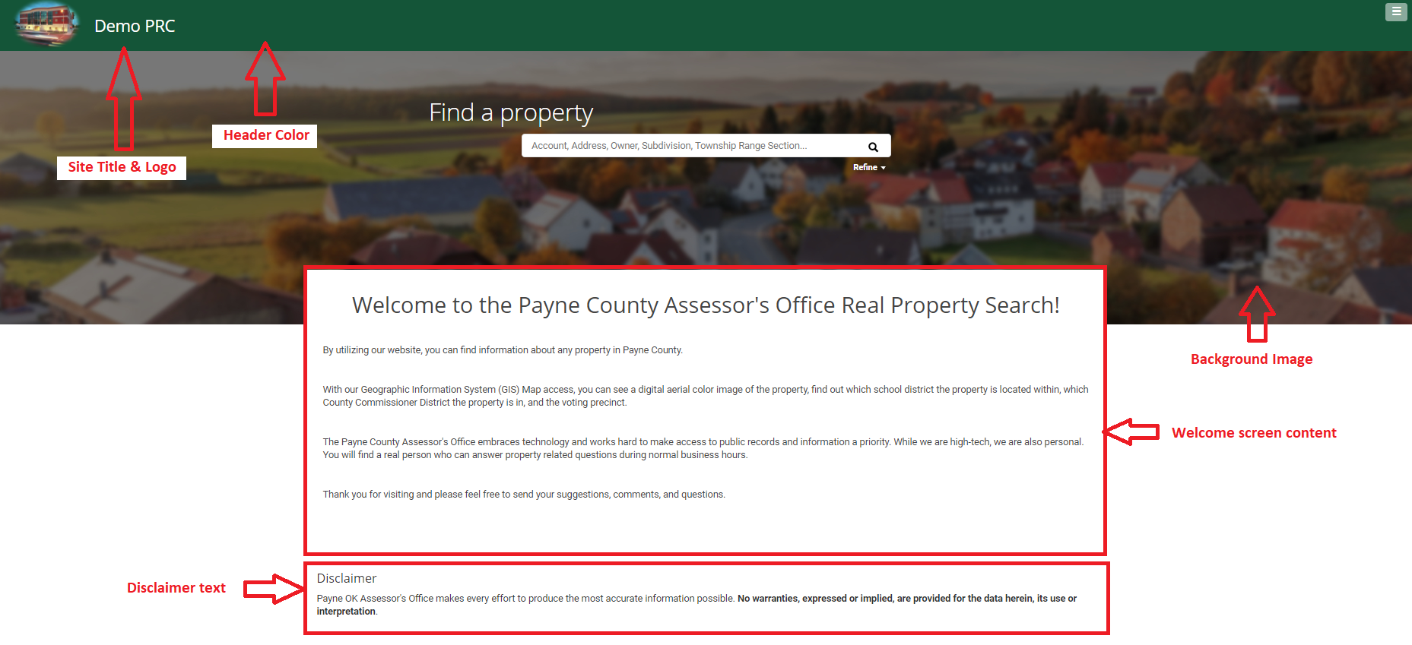
Figure 1

Search and Search Results.

- The search results consist of a thumbnail, 3 items of information max and the assessed value. What information should be display here? Generally, Parcel ID, Owner and Location is shown for example (Result list, Figure 2) Looks good.
- What fields can a user search in the search bar? Parcel ID, Location, Owner etc Do we want by Owner? Or just by Parcel ID, Geo ID or Address? The Below information is what a person can currently search by.
- Search Type:
Property ID: | XXXXXX
Parcel # / Geo ID: | Geo Parcel Number

Street Number: | 1234
Street Name: | Main
City:

Doing Business As: | Pizza Planet
- Additional Criteria
Subdivision:
Mobile Home Park:
Condo:
Township:
Range:
Township Section:

- What fields should be included in the order by dropdown? Using what we have above, we can tailor it down to what we would like.
- What search filters can be applied to a search? (Search Filters, Figure 2) This can be date fields, text input, range fields or dropdown options. How it is displayed below. Sale Date, Sale Price, Year Built, Total Area or sq/ft, Lot Size, NBHD.

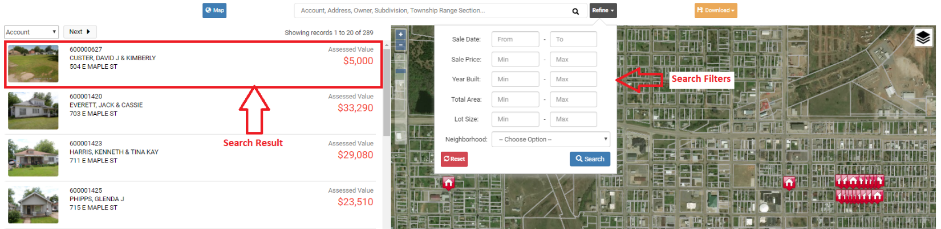
Figure 2

Record Card – Sales: Area and Neighborhood

The Area Sales view will display the closest 100 sales in the past 24 months to the property selected.
The Neighborhood Sales view will display 100 sales in the same neighborhood and in the past 24 months as the selected property. The date range can be changed to any number of months.

- What fields should be shown on the area sales view? Parcel or Geo, Prop Id, NBHD, Cycle, Sale Date, Sale Price, Living Area, Acres/Lots, Address, Distance…
- What fields should be shown on the neighborhood sales view? If this is not configured it will default to the same fields as area sales. Parcel or Geo, Prop Id, NBHD, Cycle, Sale Date, Sale Price, Living Area, Acres/Lots, Address, Distance…

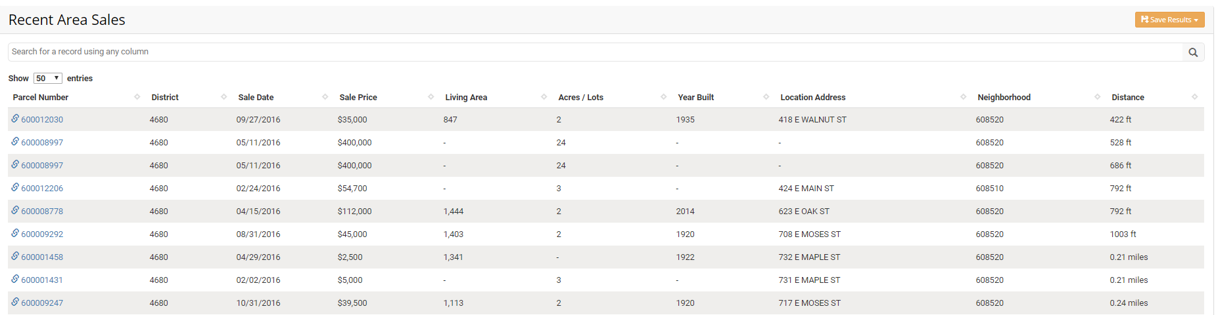

Record Card Information.

- The header consists of 3 sections max. (Header Section, Figure 3) This Looks Good
    - Parcel ID & Property location
    - Mailing Address
    - Value (Assessed/Market)

Parcel ID and value can be changed. Good
The highlight color can also be changed on request. Good

- What information should be displayed in the Key Information section? (Key Information, Figure 3). This section has no data limit. The section title can be changed, and a tooltip added if required. Good Information here, but would like to edit some of these. Like probably don’t need homestead in there. Maybe don’t even need tax district?

- What information should be displayed in Assessment Details section? (Assessment Details, Figure 3). This section has no data limit. The section title can be changed, and a tooltip added if required. Good Information here too. Would like to edit a little bit.

- External links can be added to the Navigation bar i.e. other products, other tools. Awesome

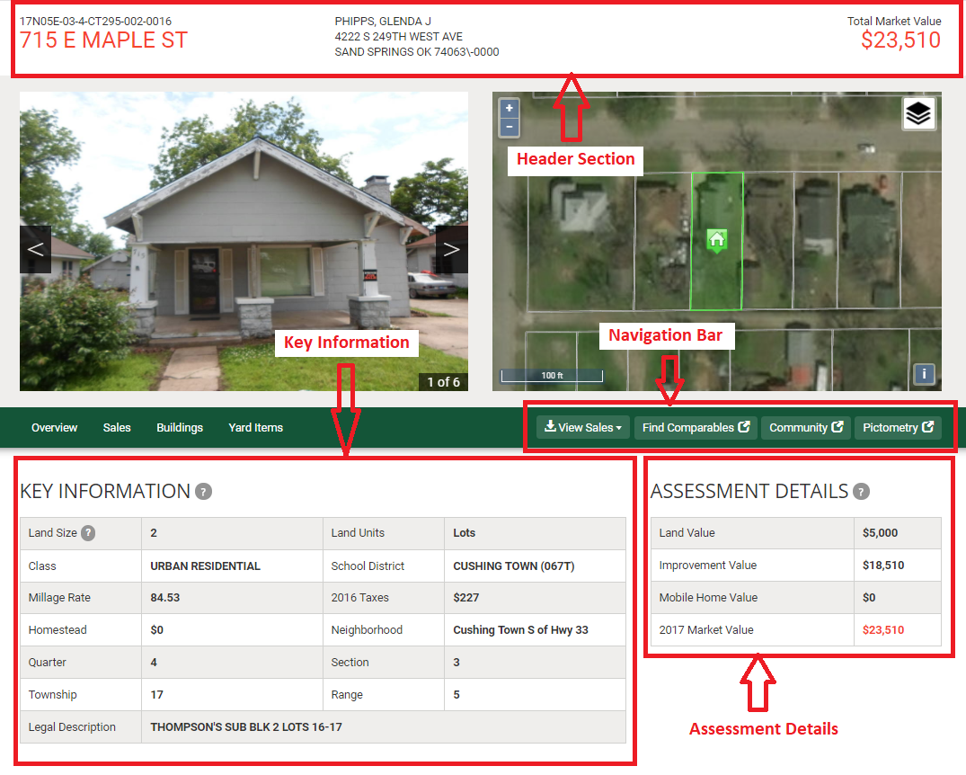 Figure 3 – Property Summary

Record Card Information - Buildings.

- What information is required for the buildings section? (Building Details, Figure 4). This section has no data limit. The section title can be changed, and a tooltip added if required. Like what is listed below. Type, Style, Qlty, Cond, Bed/Bathrooms, sq/ft, year built, siding and roofing type…

- What information is required for the improvements section? (Improvements, Figure 4). This section has no data limit. The section title can be changed if required. Yes, like the detail features, pole bldgs, pools, covered porches, decks…etc.

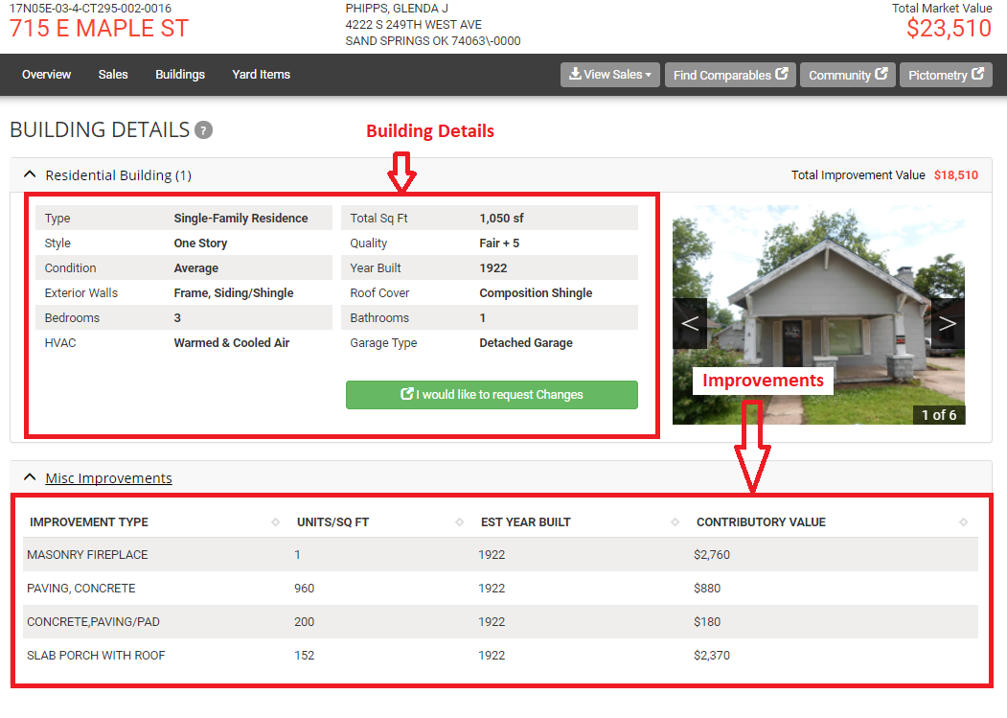
Figure 4 – Building details

Record Card Information – Change Request

- Is the change request functionality required? It isn’t required but would like to have.
- If so, what property characteristics are required? (Figure 5) What is listed below looks good for now.
- What is the adjourn date? What is meant here?
- What email address should be used for notifications of change requests? assessor@co.benton.wa.us – is this what we want to use?
- What text should be displayed for the “Equalization Reminder”? What is meant here?

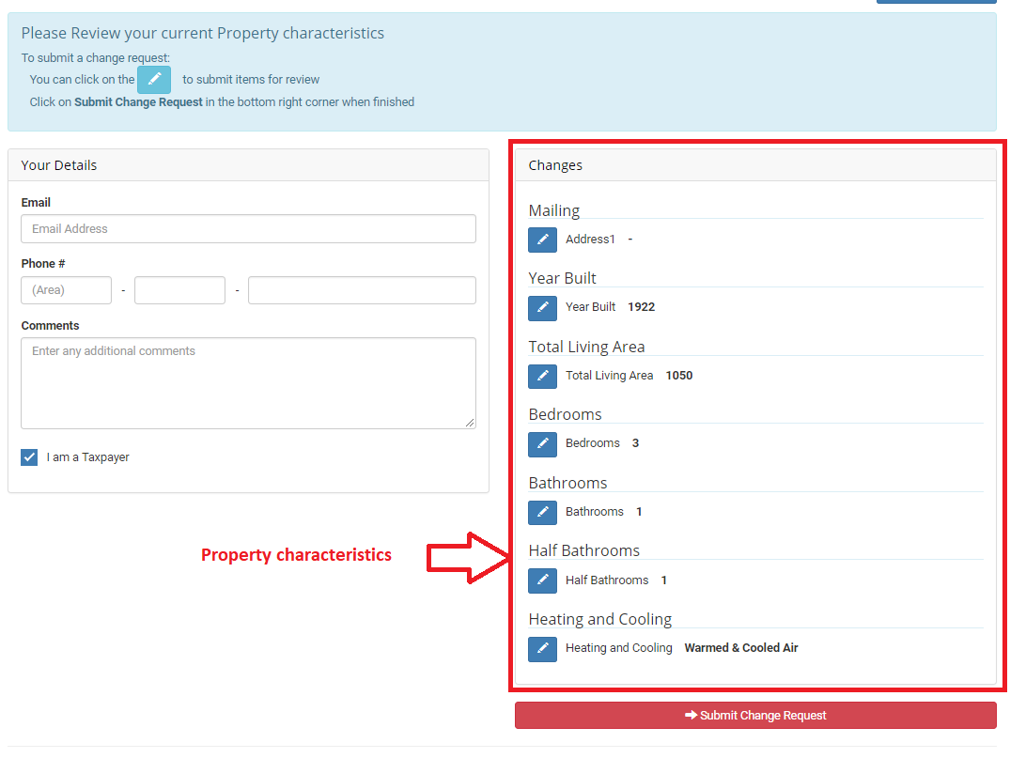
Figure 5 – Change Request

Record Card Information – Additional Tabs

Additional tabs can be added if required.

- Title (required) Good
- Tooltip (optional) Does this walk through how to do or?
- Pre-content – A paragraph can be added above the data table (optional)
- Data to show (required) like below, Sale Date/Price, Excise Number or recording number, Deed Type, Grantor and Grantee?

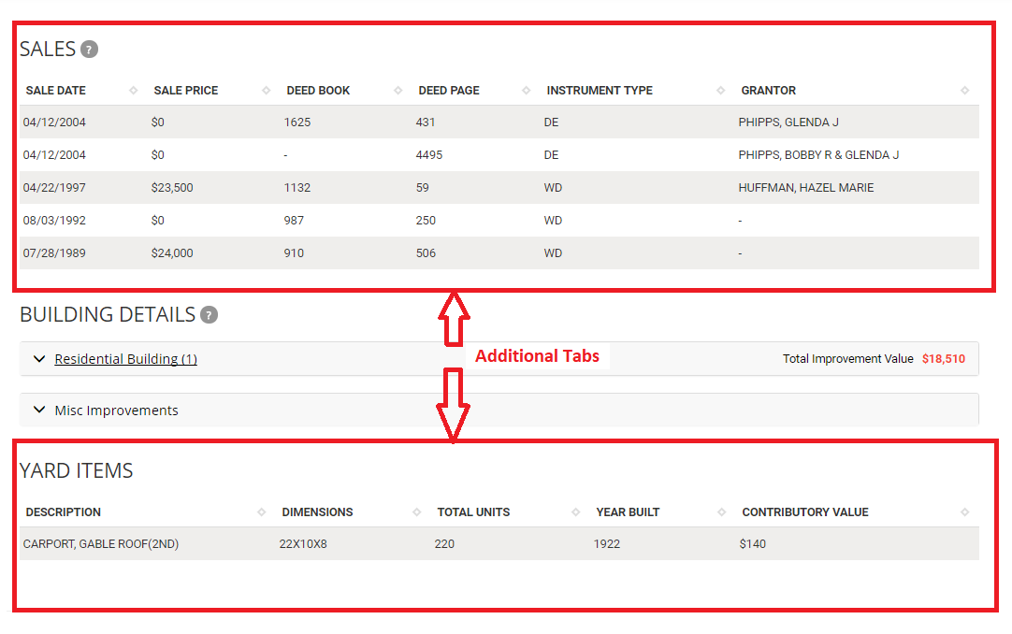
Figure 6 – Additional tabs

Map

- What additional Map Layers are required? Links to shapefiles etc. Will need to think about what layers we would like out there. Parcel or PID, Satellite imagery and non…

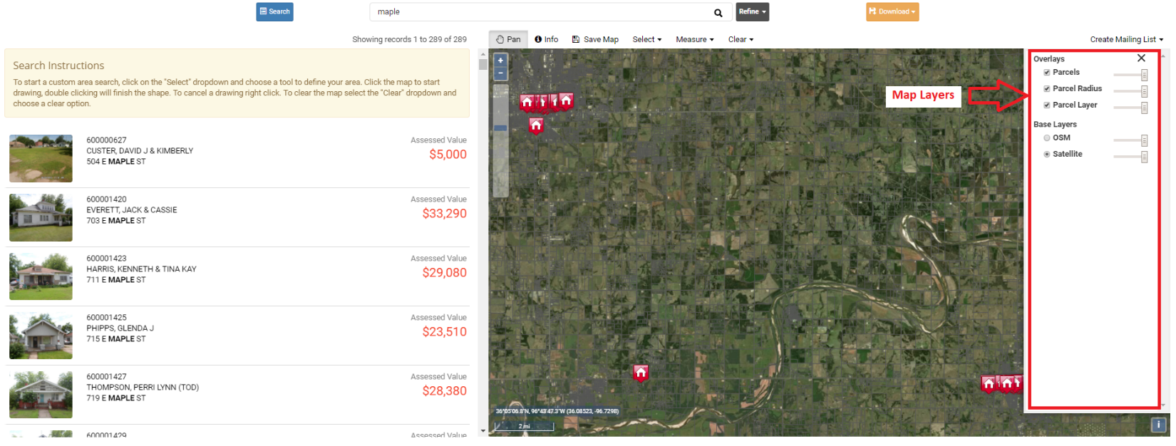
Figure 7 – Map view

